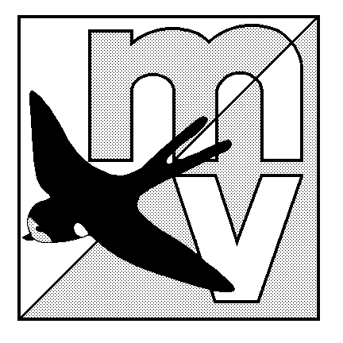
MOLE VALLEY ORIENTEERING CLUB

RANMORE BADGE EVENT/SOUTH EAST LEAGUE

7 January 2001
VENUE: Ranmore Common, north west of Dorking on the North Downs. Map based on 1998 map, modified autumn 2000 by Mike Elliot.
PARKING: At Friends Provident offices just off A24, near Dorking station – grid ref. TQ 172506. Signed from A24. Parking on hard standing. No extra car park charge. Bussing up to Ranmore area.
COURSES: Full Badge courses: M/W 10 – 18 A/B; M/W 21-75 L/S. Master maps will be used for courses, not over-printing. (Sorry). Limited Colour coded courses for EOD . String course. NB: Remember to use 2001 age classes!!
FACILITIES: Use of Friends Provident Sports and Social Club toilets, changing facilities, showers and bar! Porta-loos near start area.
FEES/ Fees: Badge courses: Seniors £6.50, Juniors £2.50. Pre-entries to: Nick Green,
ENTRIES: 9, Kenyons, West Horsley, Leatherhead, Surrey KT24 6HX. e-mail: njgreen@btinternet.com. Tel: 01483 285861, 8 –10 pm only. Cheques payable to Mole Valley OC. Closing date: post-marked 19 December 2000. Late entries - Badge: £1 surcharge seniors, 50p surcharge juniors.
Colour coded EOD only: Senior £3.50, Junior £2.00.
OFFICIALS: Organiser: John Davies - 01737 240713; e-mail davies.dj@virgin.net
Planner: Nigel Bush (MV)
Controller: Mike Murray(SLOW)

Further details will be posted on the MV web site: www.users.dircon.co.uk/~svogel/
All competitors take part at their own risk and are responsible for their own safety

Entry for: MOLE VALLEY OC RANMORE BADGE EVENT on 7 January 2001
 |  | CONTACT NAME:
Address:
Postcode:
Phone: e-mail:
DATA PROTECTION ACT: Details may be stored on computer. It may not be possible to process an
entry for anyone who objects to having their details so recorded.
BOF No. | CLASS |  | NAME  (20 letters max., forename first) |  |  |  | CLUB |  | START  (E/M/L) | BIRTH YR. | FEE
No. of sets of Pre-race information: |  |  |  |  | No. of sets of  results: |  |  | Total fee enclosed |  |  | £
Please tick for split times for parents (indicate Early/Late above)
Please tick if any entrant/s running out of class
Please enclose two SAEs (at least 9” x 6”) and cheque made payable to Mole Valley OC

